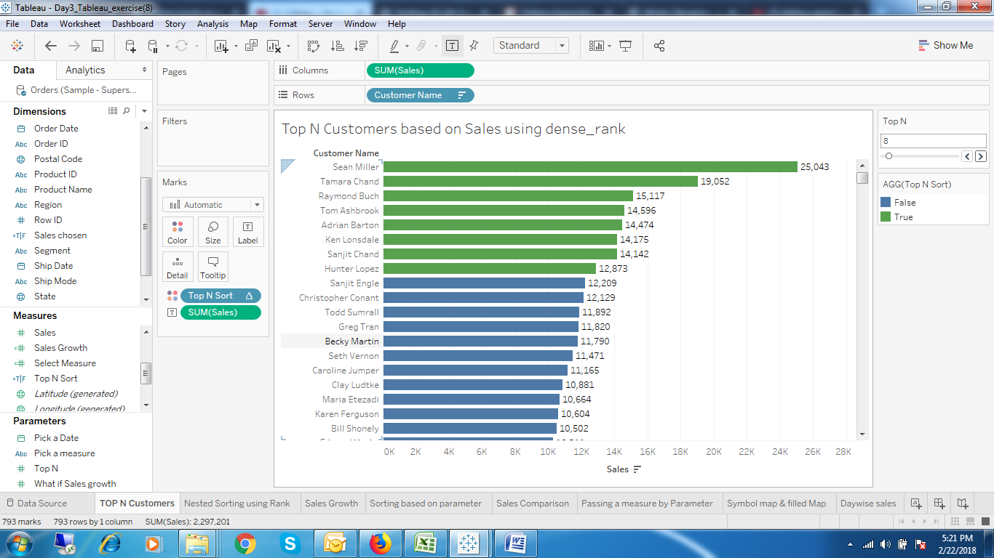

1. Top N Customers based on Sales with Different Colours

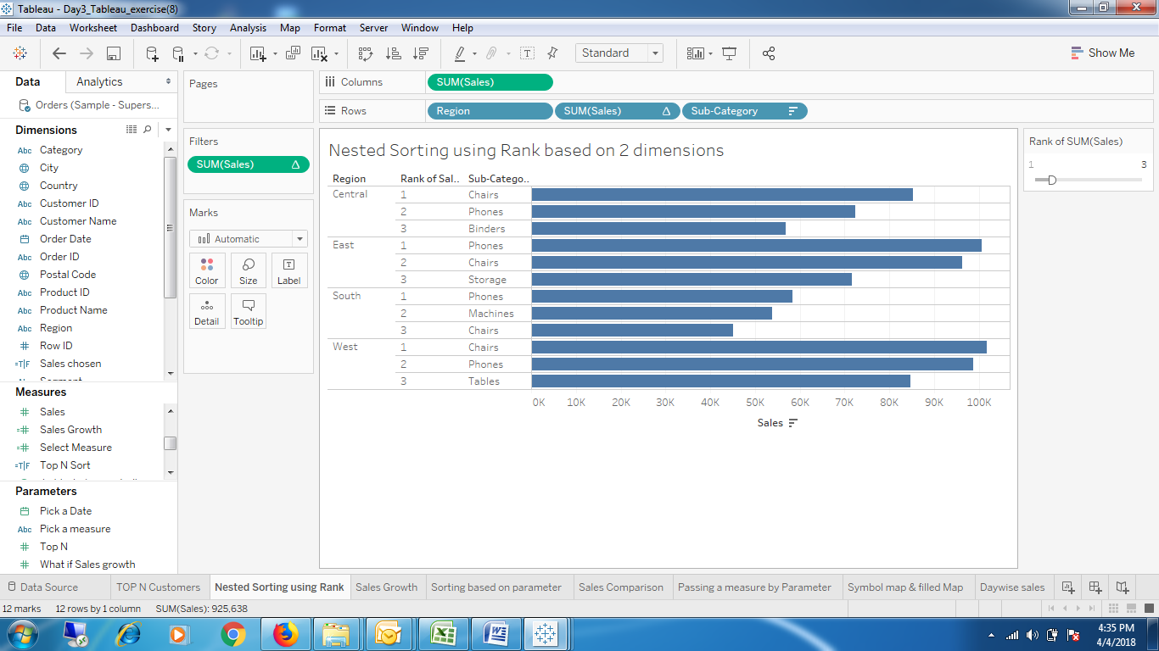

1. Regionwise Subcategorywise Top N based on Sales

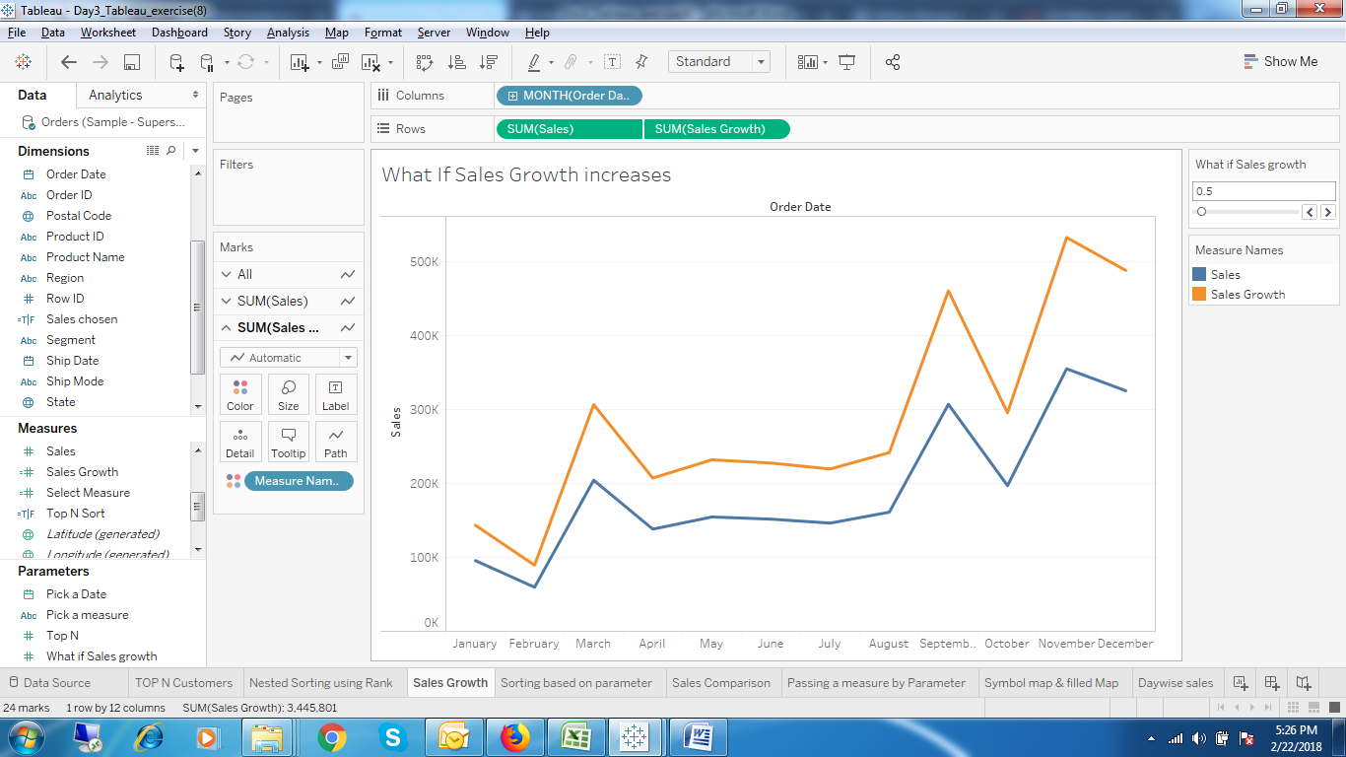

1. Monthwise sales and the sales Growth (What if Analysis)

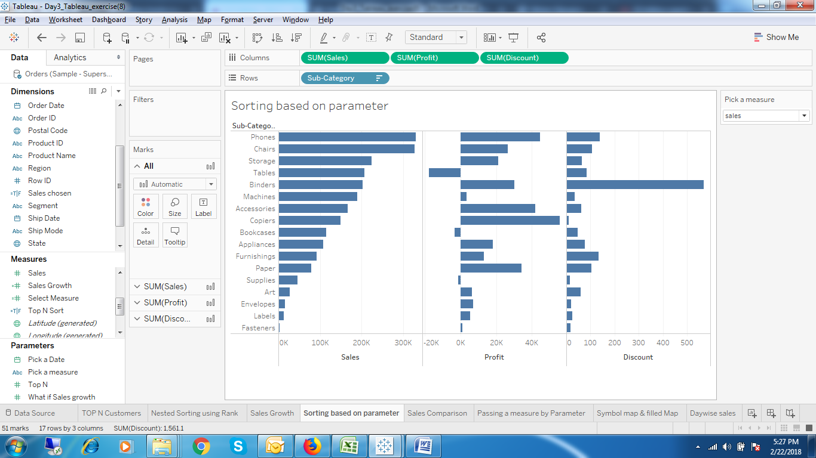

1. Sorting Based on Parameter

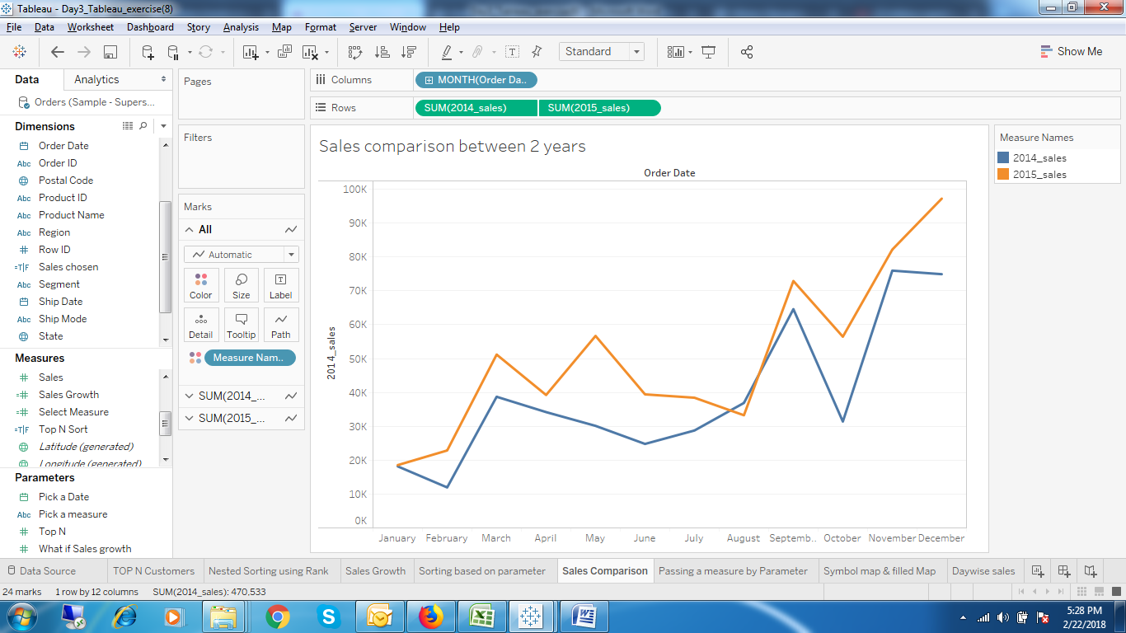

1. Monthwise 2014 and 2015 Sales

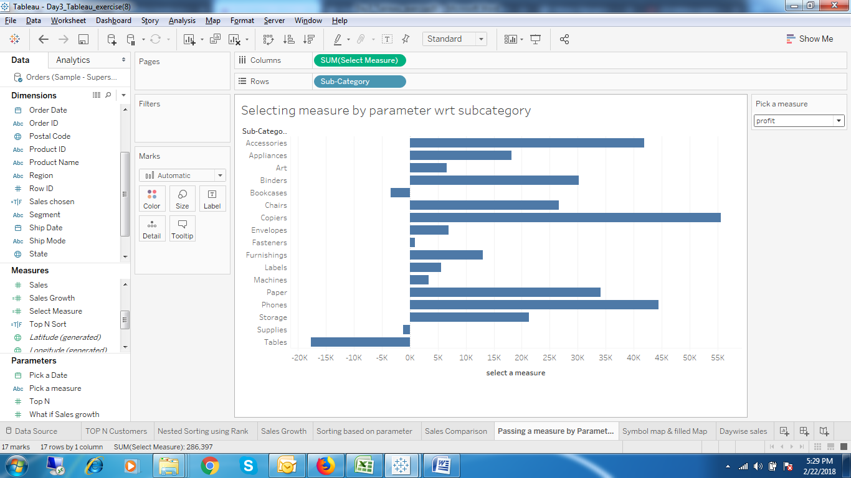

1. Different metric based on Subcategory

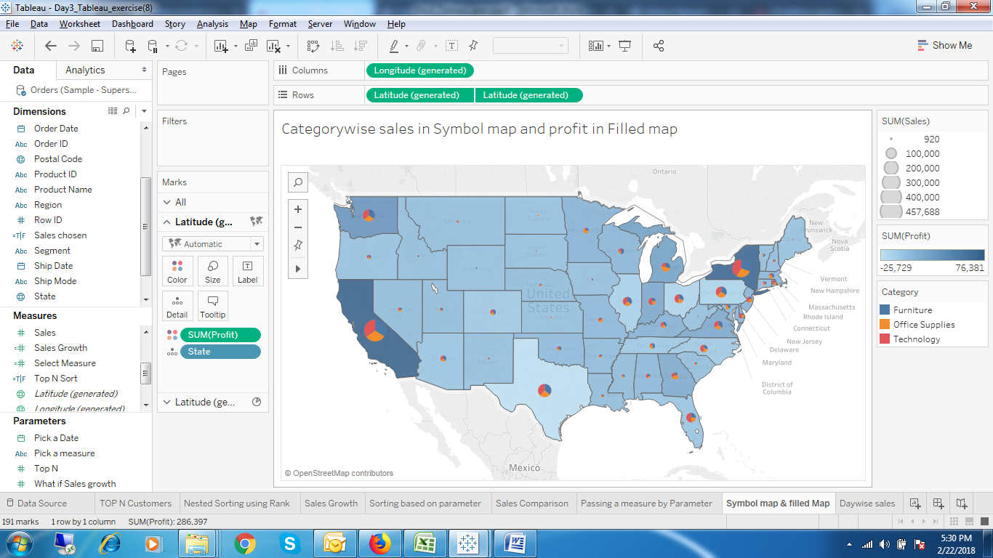

1. Categorywise Sales and Profit in 2 different Maps

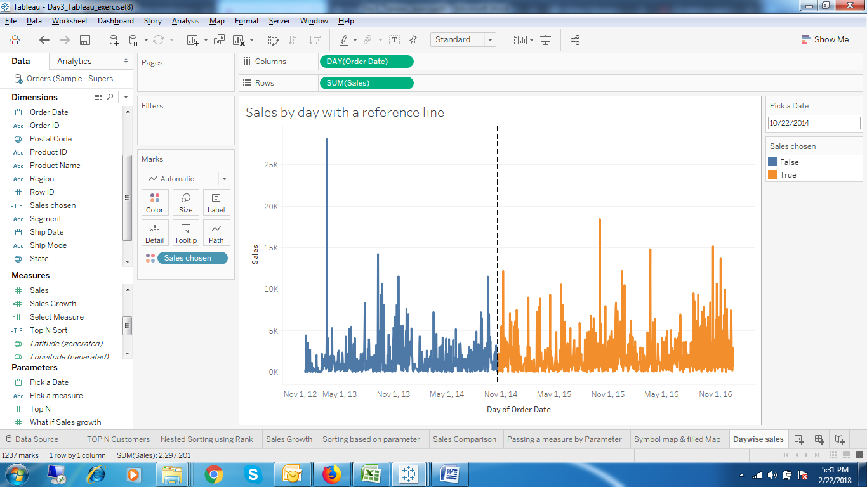

1. Daywise Sales with a reference line.

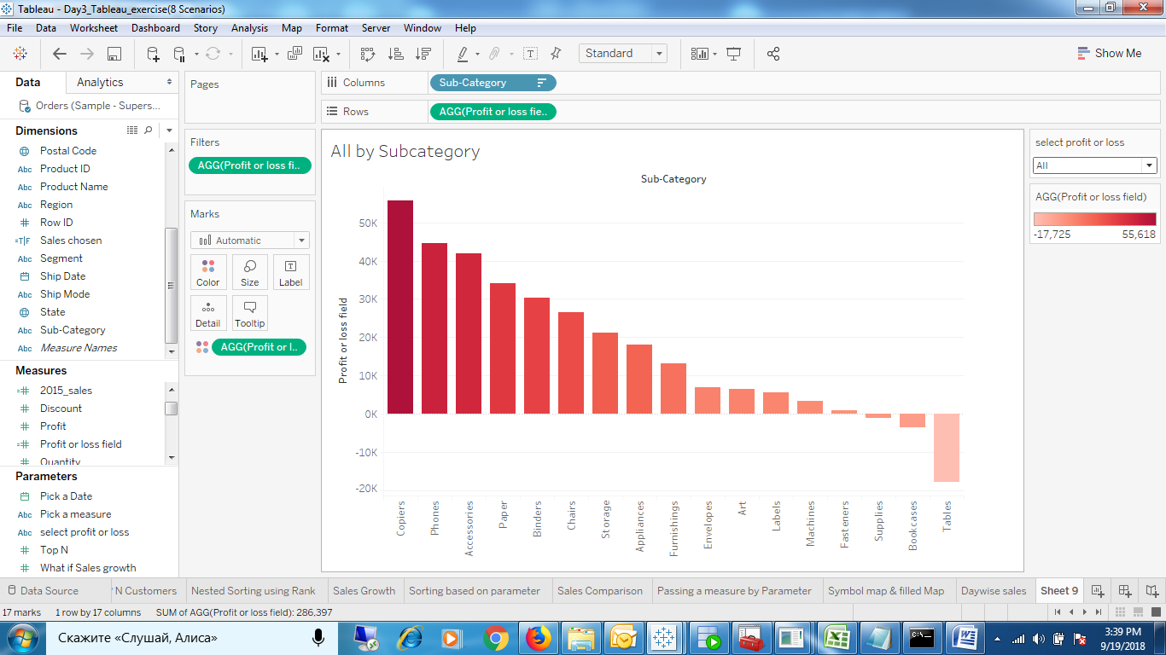

1. Subcategorywise Profit or Loss or All

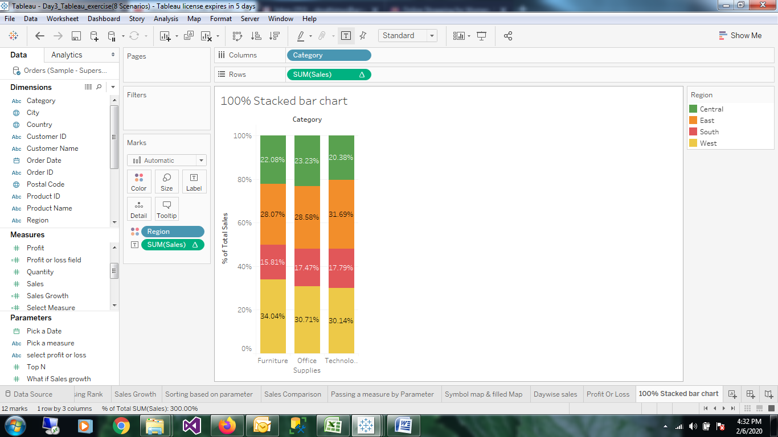

1. Display a 100% stacked bar chart

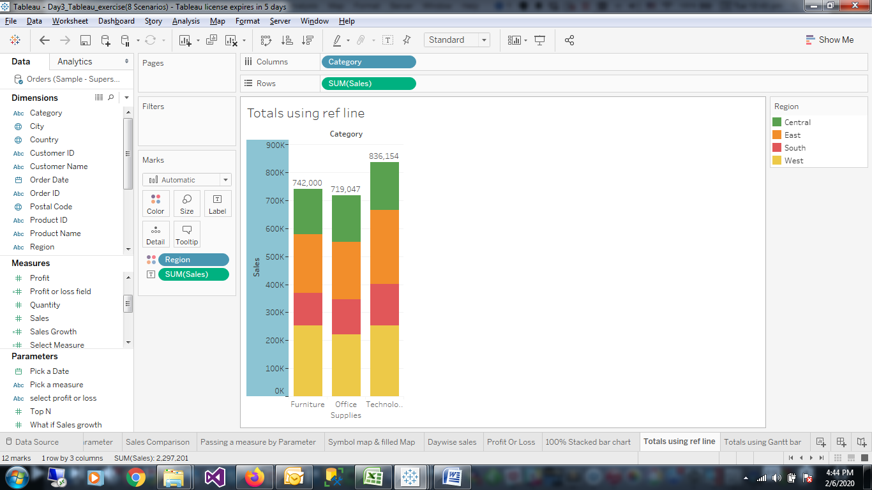

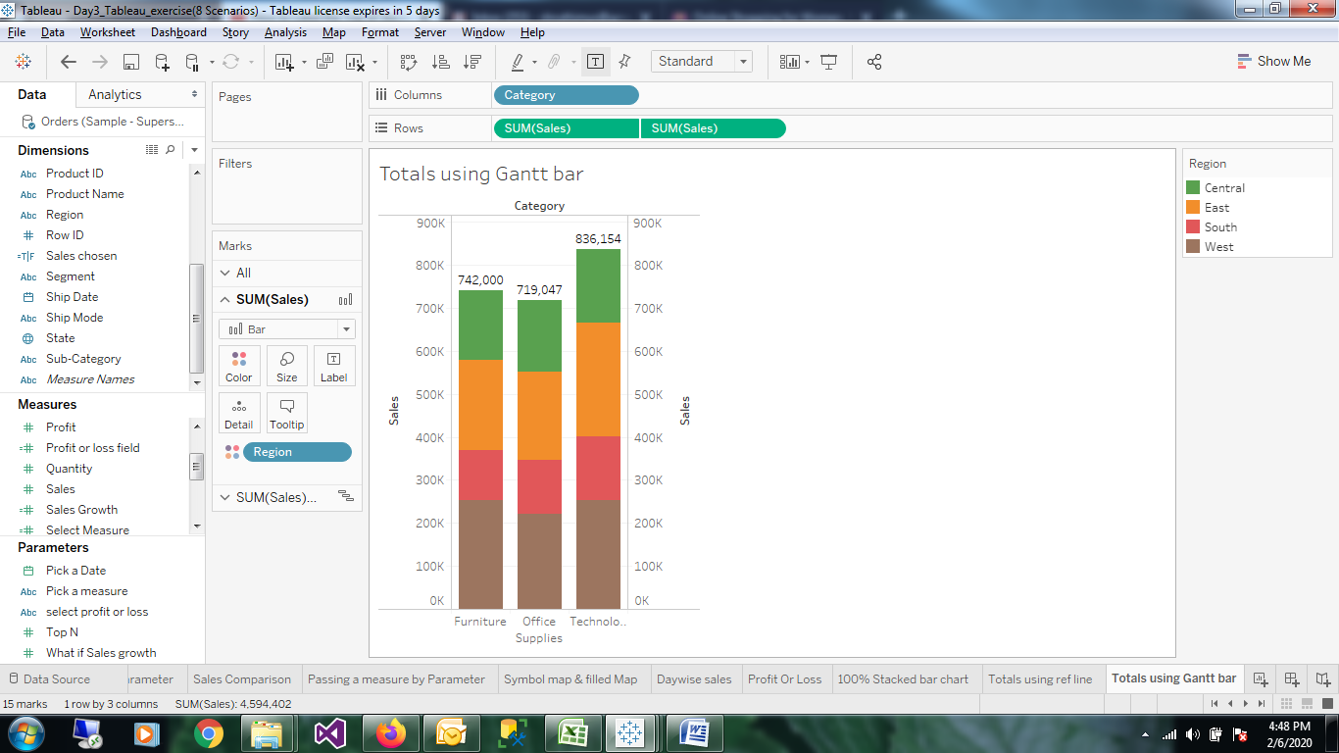

1. Displaying total on the head of the bar(gantt bar or reference line).